# Testing the input query works for the log function

|  |  |
| --- | --- |
| **State of PHP Variables** | |
| UName | tasogare |
| Time | 14:05:09 |
| Desc | An account called ‘AccountID’ was created |



The query that adds a new entry to the log file wasn’t working when implemented on the test page.

So I took the data from the PHP page and added it to the PhpMyAdmin SQL Application.



I tried it in the PhpMyAdmin SQL application.

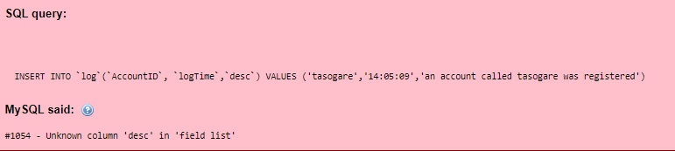

I found out that I forgot to add the ‘desc’ column when making the log table.

I then added a new column called log to the table using an alter statement.



After changing the sql query in the PHP page, it worked fine.



# Testing the Login Backend Works

|  |  |
| --- | --- |
| **State of PHP Variables** | |
| UName | akira1988 |
| Password | beefzone |

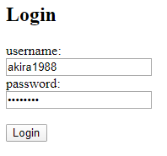

I can log into the test page



# Testing the Applicant Backend Works

